**DAILY ONLINE ACTIVITIES SUMMARY**

|  |  |  |  |
| --- | --- | --- | --- |
| **Date:** | 10/06/2020 | **Name:** | Krishnitha |
| **Sem & Sec** | 4th sem, A Section | **USN:** | 4AL18CS039 |
| **Online Test Summary** | | | |
| **Subject** | Object Oriented Concepts | | |
| **Max. Marks** | 30 | **Score** | 26 |
| **Certification Course Summary** | | | |
| **Course** | Introduction to Information Security | | |
| **Certificate Provider** | Great Learning Academy | **Duration:** | 3 hrs |
| **Coding Challenges** | | | |
| **Problem Statement:**  1) Write a C Program to rotate the matrix by K times Program in C.  2) Write a C Program to print the sum of boundary elements of a matrix.  3) Java Program to find the longest repeating sequence in a string. | | | |
| **Status:** Executed | | | |
| **Uploaded the report in GitHub** | | YES | |
| **If yes Repository name** | | <https://github.com/krishnitha/Java-coding>  <https://github.com/krishnitha/C-coding> | |
| **Uploaded the report in slack** | | YES | |

**Online Test Details:**

Today we had assessment in the subject Object-Oriented Concepts. It was based on third and fourth module of this subject. There were 15 questions of two mark each. I scored 26 out 0f 30.

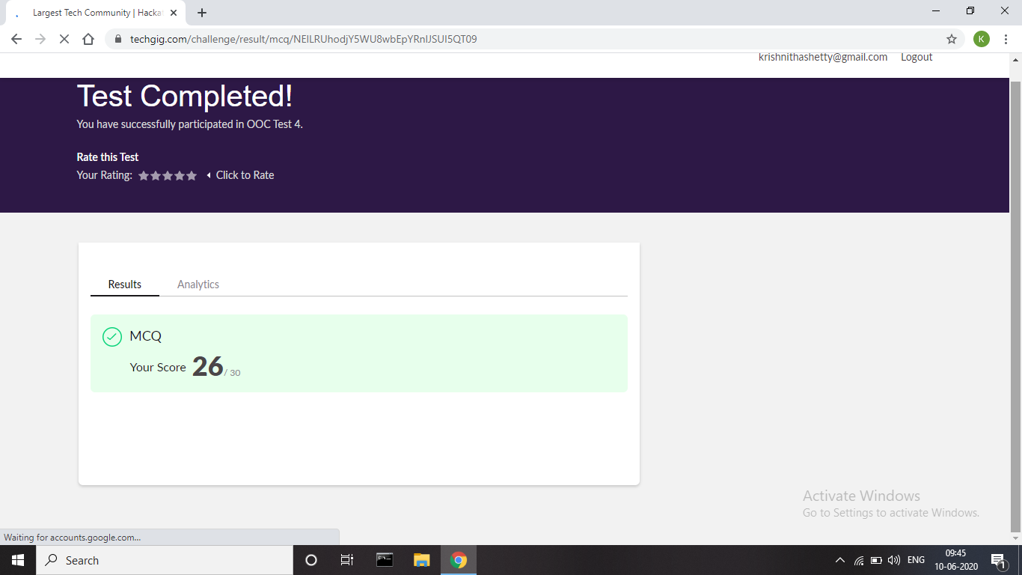

**Certification Course Details:**

Today I have done certification course Introduction to Information Security by Great Learning Academy. This course is based on basic concepts of Information Security. This course covers the application security and software security and examines what can be done in the pre-deployment phase to secure software systems.



**Coding Challenges Details:**

**Problem 1:** Write a C Program to rotate the matrix by K times Program in C

Rotate the matrix by K times means rotating the given NN matrix to the specified (K) number of times. For example, consider the 33 matrix, which has to be rotated once,  
Enter the Size of the Matrix: 3, 3  
Enter the Elements of the Matrix: 10, 20, 39, 40, 50, 60, 70, 80, 90  
Enter the value of K (Number of Rotations): 1  
Matrix before Rotation:  
10 20 30  
40 50 60  
70 80 90  
Matrix after Rotation:  
20 30 10  
50 60 40  
80 90 70

**Solution:** Uploaded it in GitHub

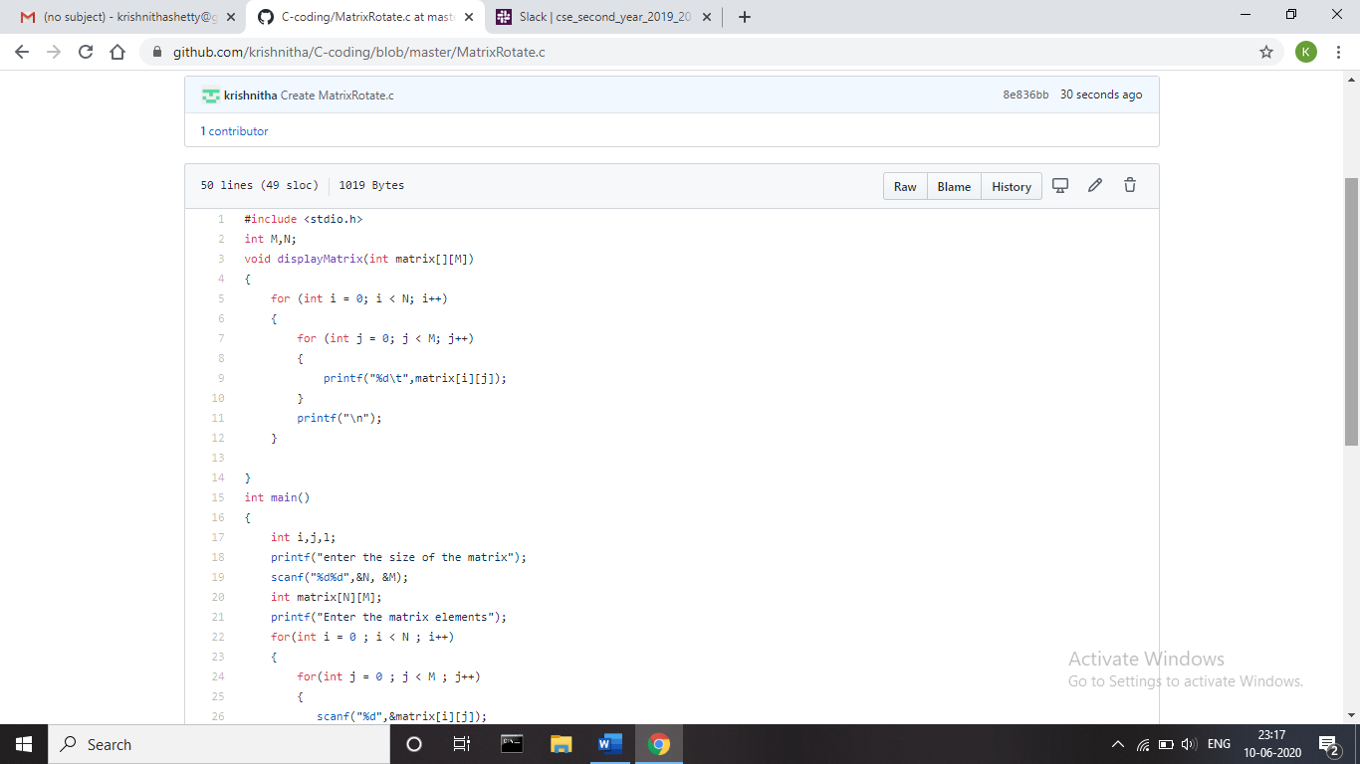

**Problem 2:** Write a C Program to print the sum of boundary elements of a matrix

Given a matrix, the task is to print the boundary elements of the matrix and display their sum.  
**Sample Output 1:**  
Enter M (Rows) and N (Columns): 3, 3  
Enter the Elements: 1 2 3 4 5 6 7 8 9  
OUTPUT:  
The Input Matrix is:  
1 2 3  
4 5 6  
7 8 9  
The Boundary Elements are: 1 2 3 4 6 7 8 9  
The Sum of Boundary elements of the Matrix is: 40

**Sample Output 2:**  
Enter M (Rows) and N (Columns): 4, 5  
Enter the Elements: 1 2 3 4 5 6 7 8 9 10 11 12 13 14 15 16 17 18 19 20  
OUTPUT:  
The Input Matrix is:  
1 2 3 4  
5 6 7 8  
9 10 11 12  
13 14 15 16  
17 18 19 20  
The Boundary Elements are: 1 2 3 4 5 8 9 12 13 16 17 18 19 20  
The Sum of Boundary elements of the Matrix is: 147

**Solution:** Uploaded it in GitHub

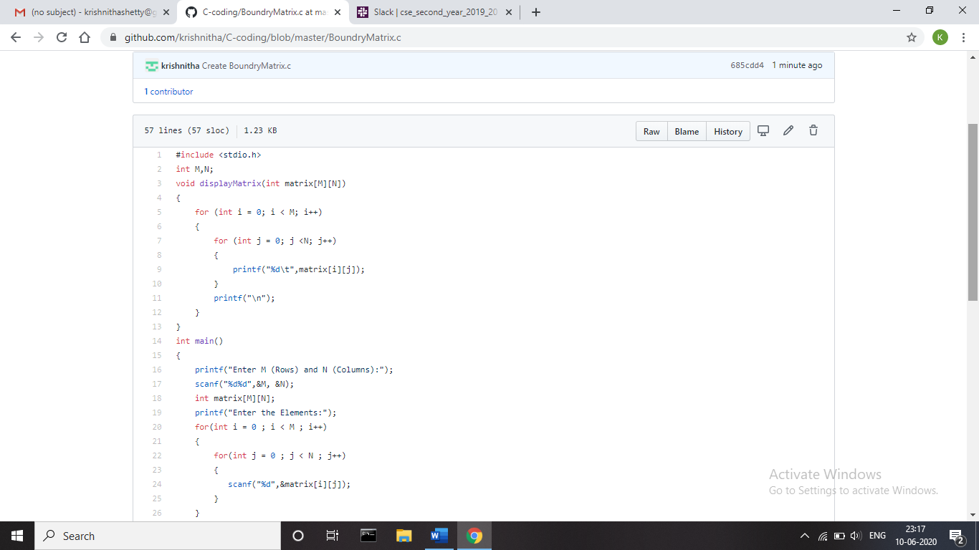

**Problem 3:** Java Program to find the longest repeating sequence in a string  
string: acbdfghybdf

**Solution:** Uploaded it in GitHub

